Survey on Housing for
Agricultural Workers in Napa County



Introduction

Hello, my name is ______. I work for the California Institute for Rural Studies. We are conducting a survey for Napa County, to identify the housing needs of agricultural workers. This information will be used to improve farmworker housing conditions. The survey takes about ½ hour. We are offering $10 to everyone that participates in they survey to thank you for your time. Everything we discuss is completely confidential, and we will not write down your name or address. Are you interested in participating in this survey?

- Where are you from?
¹ Mexico à State: ____________________________
² Other country [specify]: ____________________________
³ United States
⁴ No answer

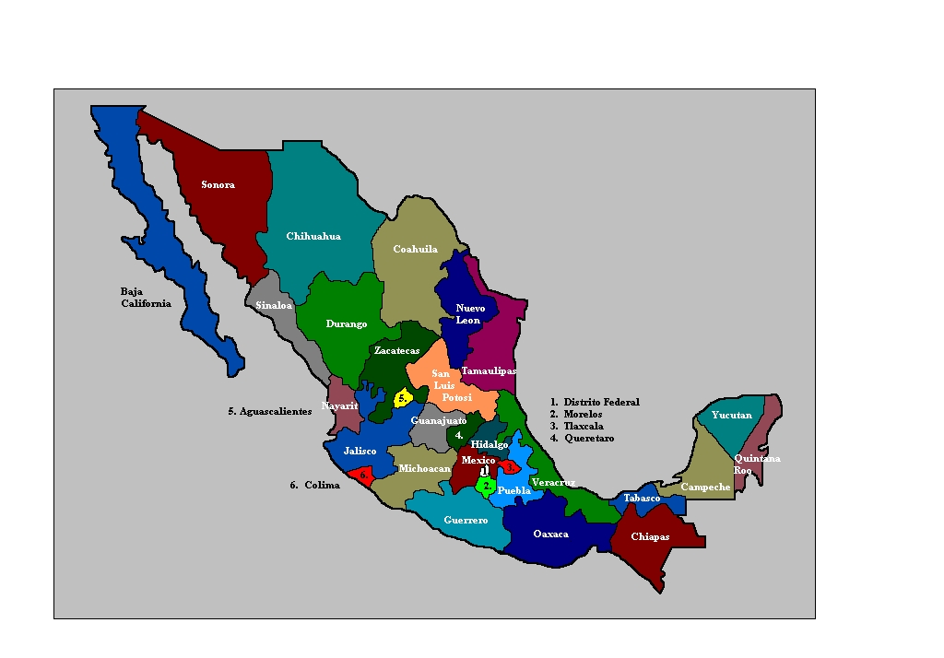
- Is your permanent residence in Napa County?

❑ Yes à Where do you live in Napa County?

City/town: __________________

à Do you have any plans to move out of Napa County during the coming year?

❑ Yes àWhy? ____________________________________

❑ No

❑ Don’t know/No answer

[GO TO QError: Reference source not found, ON PAGE Error: Reference source not found]

❑ No

INTERVIEWER:

The following cities and towns are in Napa County:
- Napa ● Deer Park
- American Canyon ● Oakville
- Calistoga ● Pope Valley
- St. Helena ● Rutherford
- Yountville ● Angwin

For more information, see the map of Napa County at the end of the survey.

- Is your permanent residence outside of Napa County?

❑ Yes à Where is your permanent residence?

City/town: __________________________

❑ No permanent residence, follows the crops [GO TO QError: Reference source not found]

- During the week, when you work in Napa County, do you travel from your permanent place of residence every day, or do you stay somewhere in or near Napa County?

¹ Travels from permanent residence every day [GO TO QError: Reference source not found]

² Stays somewhere in or near Napa County

- Is the place that you stay during the week when working in Napa County in Napa County?

¹ Yes, it’s in Napa County
à Where?

City/town: __________________________
[GO TO QError: Reference source not found, ON PAGE Error: Reference source not found]

² No, it’s outside of Napa County
à Where?

City/town: __________________________

³ Stays in various cities/towns

- Why don’t you stay in Napa County while working here?
[CHECK ALL THAT APPLY]
¹ Lives somewhere else and can travel to Napa from there
² Stays with family/friends somewhere else and can travel to Napa from there
³ Can’t find anywhere to stay in Napa County
⁴ Too expensive
⁵ Other [specify]:__________________________________________
⁶ Don’t know/No answer

- Would you prefer to have your permanent residence in Napa County if possible?
❑ Yes
❑ No [GO TO QError: Reference source not found]
❑ Don’t know/No answer [GO TO QError: Reference source not found]
❑ Not applicable, no permanent residence [GO TO QError: Reference source not found]

- Do you have any plans to move to Napa County?
❑ Yes
❑ No
❑ Don’t know/No answer

- The following questions have to do with the place you stay during the week, while working in Napa County, that is... [CONFIRM PLACE]

How long does it take you to get to work from the place you stay during the week while working in Napa County (one way)?

______ hours _____ minutes

❑ Don’t know/No answer

- How do you get to work? [CHECK ALL THAT APPLY]
¹ Own car
² Ride with friends/family
³ “Raitero” (person who charges for rides)
⁴ Public transportation
⁵ Walks
⁶ Bicycle
⁷ Other [specify]: _________________________

- How much do you spend traveling to work, round trip?

$_________ per  day  week  month

❑ Don’t know/No answer

- During the week, while working in Napa County, in what type of housing do you live?
¹ House
² Apartment
³ Trailer
⁴ Room in the owner’s house
⁵ Garage
⁶ Motel
⁷ Labor camp
→Which?: ¹ Calistoga ² River Ranch ³ Mondavi
Other [specify]: ________________________________
⁸ Car, tent, homeless shelter, street, etc.
→ Specify: ___________________________
⁹ Other [describe]:____________________________
¹⁰  No answer

- Do you live on the farm where you work?

❑ Yes  No  No answer

- Who do you currently live with – that is, in the place where you stay during the week while working in Napa County? [READ OPTIONS, CHECK ALL THAT APPLY]

 |  | How Many?
- Spouse or partner | ❑ Yes  No
- Children under 18 (yours or your partner’s) | ❑ Yes  No
- Children over 18 (yours or your partner’s) | ❑ Yes  No
- Your parents | ❑ Yes  No
- Other relatives | ❑ Yes  No
- Other non-relatives | ❑ Yes  No

IF RESPONDENT DOES NOT LIVE WITH HIS/HER SPOUSE/PARTNER, OR DOES NOT LIVE WITH HIS/HER CHILDREN, GO TO THE NEXT TABLE. IF LIVES WITH FAMILY, GO TO NEXT PAGE.

- Do you have...? | IF YES: Where do they live? | - Would you prefer that they lived here with you?
A. Spouse/partner:   Yes  No | City/town:  ______________________  Country: ______________ | ❑ Yes  No
B. Children under 18 (yours or your partner’s):   Yes  No | City/town:  ______________________  Country: ______________ | ❑ Yes  No

- Do you rent, own or borrow the place you stay during the week, while working in Napa County?
¹ Rent [GO TO QError: Reference source not found]
² Own [GO TO QError: Reference source not found]
³ Borrow [GO TO QError: Reference source not found]
IF RENT...

- How much is your share of the rent in the place you stay during the week, while working in Napa County?

$_______ per  day  week  month

❑ No answer

- How many people are included in the rent (including yourself)? _______

- Do you pay rent for the entire dwelling, or do you share with others?
¹ I pay the entire rent
² I share the rent with others
→ How much is the total rent for the entire dwelling?
$ _________ per  day  week  month
❑ Don’t know/No answer

- Is the rental agreement in your (or your spouse/partner’s) name?

❑ Yes  No  Don’t know/No answer

- Are any of the utility bills (electricity, gas, or telephone) in your (or your spouse/partner’s) name?

❑ Yes  No  Don’t know/No answer

[GO TO QError: Reference source not found]

If owner...

- How much is your share of the mortgage?

$ _________

❑ No answer

- Do you own the house yourself, or did you buy it with others?

¹ Own house
² Bought with others
→ What is the mortgage for the entire house?
$ _________
❑ Don’t know/No answer

- Do you receive any income from renters?
❑ Yes à How much? $________ per  day  week  month
❑ Don’t know/No answer
❑ No

- How much is your monthly payment for each of the following services in the place you stay during the week while working in Napa County?

A. Gas and electricity  (PG&E) | $ ________ | ❑ Nothing, included in rent | ❑ Don’t know
B. Water | $ ________ | ❑ Nothing, included in rent | ❑ Don’t know
C. Trash | $ ________ | ❑ Nothing, included in rent | ❑ Don’t know

IF EVERYTHING IS PAID TOGETHER:

Electricity, gas, water and trash | $ ________ | ❑ Nothing, included in rent | ❑ Don’t know

- Not counting bathrooms, how many rooms are there in the place where you stay during the week, while working in Napa County?

# ______

- How many bedrooms are there?

# ______

- Does anyone sleep in any rooms in addition to the bedrooms?

❑ Yes à Which other rooms are used for sleeping? [CHECK ALL THAT APPLY]
❑ Living room  Dining room  Kitchen  Hallway  Garage

❑ Other [specify]: ___________________________

❑ No
- Do you have the following amenities in the place you stay during the week, while working in Napa County? Please let me know if anything doesn’t work.

 | Have? | Functioning?
Hot running water | ❑ Yes  No | ❑ Yes  No
Cold running water | ❑ Yes  No | ❑ Yes  No
Flush toilet | ❑ Yes  No | ❑ Yes  No
Bath or shower | ❑ Yes  No | ❑ Yes  No
Stove | ❑ Yes  No | ❑ Yes  No
Hot plate | ❑ Yes  No | ❑ Yes  No
Refrigerator | ❑ Yes  No | ❑ Yes  No
Central heat (not space heater) | ❑ Yes  No | ❑ Yes  No
Air conditioning | ❑ Yes  No | ❑ Yes  No
Telephone (land or cell) | ❑ Yes  No

- Have you had any of the following problems during the past two years, in any place you’ve lived in while working in Napa County? [READ OPTIONS, CHECK ALL THAT APPLY]

[iF RESPONDENT IS A HOMEOWNER, GO TO E]

You asked the owner for repairs and:  They took a long time, or  Refused to make the repairs | ❑ Yes  No   Yes  No
You had problems but didn’t ask the owner to repair them for fear of being evicted | ❑ Yes  No
You were refused housing because you didn’t have money for the deposit | ❑ Yes  No
- You were refused housing for being a farmworker | ❑ Yes  No
- You couldn’t pay the rent or mortgage because someone you lived with couldn’t pay their part | ❑ Yes  No
- You couldn’t get health or social services for lack of documents with your name and address, e.g. rental agreement or utility bill | ❑ Yes  No
- You suffered high levels of stress due to excessive noise or lack of privacy | ❑ Yes  No
- You had health problems associated with dampness, such as mold in your dwelling | ❑ Yes  No

- Have you had any other housing problems during the past two years, anywhere you’ve lived while working in Napa County?

❑ Yes
→Which? _______________________________________________

________________________________________________

❑ No

❑ Don’t know/No answer

- During the past 12 months, have you had any problems paying the rent or mortgage in any place you’ve lived while working in Napa County?
❑ Yes
❑ No [GO TO QError: Reference source not found]
❑ Don’t know/No answer [GO TO QError: Reference source not found]
❑ Not applicable, is borrowing a place [GO TO QError: Reference source not found]

- How did you pay the rent or mortgage? [read options, CHECK ALL THAT APPLY]
¹ Borrowed → From who? [CHECK ALL THAT APPLY]
¹ Family or friends
² Employer
³ Private moneylender
⁴ Bank
⁵ Community based organization
⁶ Other [specify]: ________________________
² Took a “payday loan”
³ Took a credit card advance
⁴ Received emergency rental assistance
⁵ Sought other housemates to share the rent
⁶ Spent less on other necessities, such as food or health care
⁷ Other [specify]: __________________________________________

if borrowed or used credit card, go to QError: Reference source not found. otherwise, GO TO QError: Reference source not found.
- How many times during the past 12 months did you take a loan or credit card advance to pay the rent or mortgage?

# _____

- Thinking about the last time you took a loan or credit card advance:

How much was it for?

$_______

❑ Don’t know/No answer

Were you charged interest?

❑ Yes → How much? ______% per  day  week  month  year

❑ Don’t know/No answer

❑ No

- In the past 12 months, did you ever spend less on food or health care in order to pay the rent or mortgage on a place where you lived while working in Napa County?

❑ Yes

❑ No

❑ Don’t know/No answer

- Have you heard of programs that offer reduced rent or rental assistance for low income people? For example, HUD, Section 8, public housing for farmworkers or emergency rental assistance.

❑ Yes → Which program(s)? ______________________________

❑ No

❑ Don’t know/No answer

- Have you ever stayed in a labor camp in Napa County?

❑ Yes → Do you think you might stay there again sometime?

❑ Yes [GO TO QError: Reference source not found]

❑ No

❑ Don’t know/No answer
❑ No
❑ Don’t know/No answer

- Why...[CHOOSE APPROPRIATE PHRASE]

- ...wouldn’t you stay in a labor camp again?
- ...haven’t you ever stayed in a labor camp?

[CHECK ALL THAT APPLY]
¹ Hasn’t heard of labor camps
² No room
³ Too expensive
⁴ Location – not accessible to work
⁵ Location – not accessible to other services (shopping, school, etc.)
⁶ Works at night – can’t get in
⁷ Can’t have outside guests
⁸ Can’t consume alcohol
⁹ Can’t play loud music
¹⁰ Doesn’t like food
¹¹ Doesn’t want to pay for food
¹² Not open all year
¹³ Doesn’t want others to interfere with housing situation
¹⁴ No family housing
¹⁵ They don’t accept people without legal documents
¹⁶ Other [specify]: ________________________________________

________________________________________

- Did you return to Mexico or your country of origin during the past winter?

❑ Yes à [GO TO QError: Reference source not found]

❑ No

❑ No answer

- Did you spend the winter in Napa County or somewhere else?

¹ Napa County

² Somewhere else

- Were you unemployed at all last winter?

❑ Yes

❑ No [GO TO QError: Reference source not found]

❑ No answer [GO TO QError: Reference source not found]

- For how long were you unemployed? ______  weeks  months

❑ Don’t know/No answer
- How did you pay the rent during that time? [CHECK ALL THAT APPLY]
¹ Used personal savings
² Spouse/partner was working
³ Had income from unemployment insurance
⁴ Took a loan
⁵ Lived with more people to reduce costs
⁶ Spent less on other necessities
⁷ Was unable to remain in that dwelling
⁸ Other [specify]: ________________________________________

EMPLOYMENT AND INCOME
- I have some questions about your current job. What is your current position?

¹ Field worker
² Specialized – irrigation, tractor driver, pesticide applicator, etc.
³ Foreman/supervisor
⁴ Other [specify]: __________________________________

- Right now, during the harvest, are you paid by the hour, piece-rate or salary?

¹ Hourly → How much do you earn per hour? $_____________

How many hours did you work last week? _______

² Piece rate → At what rate are you paid?

$_______ per ¹ ton

² other quantity [specify]: ____________

³ Salary →What is your salary?

$_____________ per ¹ week ² two weeks ³ month ⁴ year

- Right now, during the harvest, how many hours do you work per day on average?
# _________

❑ Don’t know/No answer

- Is that enough hours?

❑ Yes  No  Don’t know/No answer

- How much was your last paycheck?

$_____________

❑ Don’t know/No answer

- How much time was that for?

¹ One day ² One week ³ Two weeks ⁴ One month

⁵ Other [specify]: ____________________________

- Approximately how much did you earn last year, before taxes and other deductions?

$_____________

❑ Don’t know/No answer

- How much of what you earned was from farm work?

❑ Everything

❑ A portion, which was: $_____________

❑ Don’t know/No answer

- IF RESPONDENT HAS A SPOUSE/PARTNER THAT LIVES IN THE US: Approximately how much did your spouse/partner earn last year, before taxes and other deductions?

$_____________

❑ Don’t know/No answer

- Did you receive any other work-related income last year, such as bonuses or profit-sharing?

❑ Yes à How much? $_________  Don’t know/No answer

❑ No

❑ Don’t know/No answer

- Did you send any money to relatives in Mexico [or your country of origin] during the past 12 months?

❑ Yes à How much did you send last month?

$_________  Don’t know/No answer

→ How much did you send during the past 12 months?

$_________  Don’t know/No answer

❑ No

❑ Don’t know/No answer

- I have a few questions about when you’ve lived or worked in Napa County during the past 12 months.

INTERVIEWER: To fill out the following table, for each month, ask if the respondent lived in Napa County and if he/she worked in Napa County. If he/she lived or worked in Napa County, ask what he/she worked at. If he/she was working, ask what type of employer he/she had and how many hours he/she worked per week on average. If he/she doesn’t know the type of employer, ask for the employer’s name.

Month | Lived in Napa County? |  | Worked in Napa County? |  | If lived or worked in Napa County: Type of work | Type of Employer | Hours worked per week
Month | Yes | No | Yes | No | If lived or worked in Napa County: Type of work | Type of Employer | Hours worked per week
August 2006 | ❑ | ❑ | ❑ | ❑
July 2006 | ❑ | ❑ | ❑ | ❑
June 2006 | ❑ | ❑ | ❑ | ❑
May 2006 | ❑ | ❑ | ❑ | ❑
April 2006 | ❑ | ❑ | ❑ | ❑
March 2006 | ❑ | ❑ | ❑ | ❑
Feb 2006 | ❑ | ❑ | ❑ | ❑
Jan 2006 | ❑ | ❑ | ❑ | ❑
Dec 2005 | ❑ | ❑ | ❑ | ❑
Nov 2005 | ❑ | ❑ | ❑ | ❑
Oct 2005 | ❑ | ❑ | ❑ | ❑

Codes for Grid

Type of Work
TC = Field work
TFA = Non-agricultural work
D = Unemployed
V = Vacation

Type of Employer
R = Grower
EMV = Vineyard Management Co.
C = Farm Labor Contractor
AT = Temporary employment agency
ESA = Custom service provider
EE = Packing house
FA = Non-agricultural employer
NS = Don’t know/No answer
NA = Not applicable

- How many distinct employers did you have, working in agriculture in Napa County during the past 12 months?

# _______

- Do you plan to work in Napa County again next year?

❑ Yes [GO TO QError: Reference source not found]

❑ No

❑ Don’t know/No answer

- Why don’t you plan to work in Napa County again next year?
[CHECK ALL THAT APPLY]
¹ Insufficient work – in general
² Insufficient work – during harvest
³ Wages have gone down
⁴ Housing is very expensive
⁵ Housing is too expensive to bring the family
⁶ Plans to find work outside of agriculture
⁷ Plans to retire
⁸ Plans to return to Mexico or country of origin
⁹ Plans to seek work in agriculture closer to permanent place of residence
¹⁰ Other [specify]: _______________________________________

DEMOGRAPHIC INFORMATION

I have a few last questions for you. I’d like to remind you that everything we discuss is completely confidential, and that you do not have to answer any questions you would prefer not to answer.

- How old are you? ______

- In which year did you come to work in the U.S. for the first time? ________

- In which year did you come to work in Napa County for the first time? ________

- Do you speak any indigenous languages (such as Mixteco, Zapoteco, etc.)?

❑ Yes à Which? _____________________

❑ No

- What is your residency status in the United States?
¹ Documented
² Undocumented
³ Documents in process
⁴ No answer

- Besides cost, what are the most important factors you consider when seeking housing in or near Napa County?

___________________________________________________________

___________________________________________________________

___________________________________________________________

___________________________________________________________

- In your opinion, how can housing for farmworkers in Napa County be improved?

___________________________________________________________

___________________________________________________________

___________________________________________________________

___________________________________________________________

- interviewer - note respondent’s gender:

¹ Male ² Female

- interviewer – confirm name of respondent’s employer

___________________________________________________________

Those are all the questions I have for you. Thank you very much for participating in this survey. Do you have any questions for me?

INterviewer: provide $10 incentive and ask respondent to sign receipt. Also, provide information sheet about housing resources.
interviewer, please provide the following information:

Interviewer name: _______________________________________

Interview date: ____________________

Do you feel the respondent provide accurate responses?

❑ Yes  No  Not sure

Interviewer notes:

_____________________________________________________________

_____________________________________________________________

_____________________________________________________________

_____________________________________________________________

_____________________________________________________________
Napa county communities

