Survey on Housing and Transportation for
Agricultural Workers in Mendocino County



Introduction

Hello, my name is ______. I work for Nuestra Casa. We offer services to farmworkers and other Latinos in this area. We are conducting a survey for Mendocino County, to identify the housing and transportation needs of agricultural workers and their families, with the goal of improving these services. The survey takes about ½ hour. We are offering a phone card worth $10 to everyone that participates in they survey to thank you for your time. Everything we discuss is completely confidential, and we will not write down your name. Are you interested in participating in this survey?

- Where were you born?
¹ Mexico à State: ____________________________
² Other country [specify]: ____________________________
³ United States
⁴ No answer
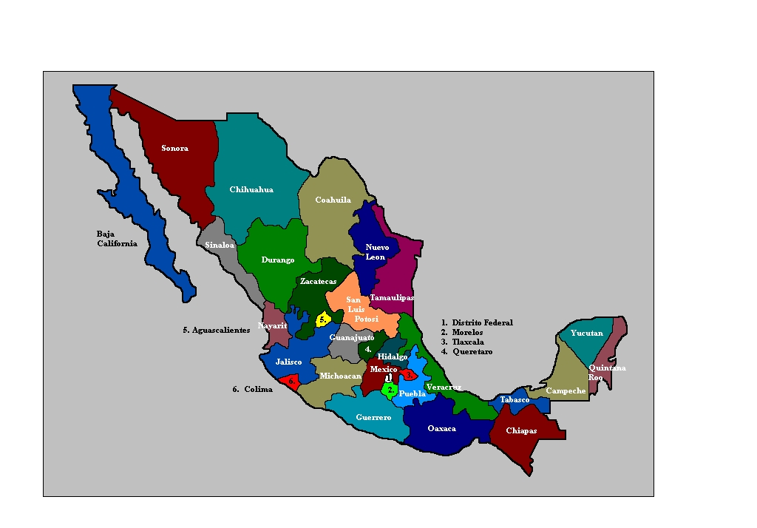
- Inside of the U.S., where do you usually live, or where is your permanent residence?

¹ Lives inside Mendocino County

à City/town: __________________________
[GO TO QUESTION 6, ON PAGE 5]

² Lives outside Mendocino County

à City/town: __________________________

³ No permanent residence, follows the harvests
INTERVIEWER: The following cities and towns are in Mendocino County.
- Albion ● Little River
- Anchor Bay ● Longvale
- Boonville ● Manchester
- Branscomb ● Mendocino
- Calpella ● Navarro
- Caspar ● Noyo
- Cleone ● Old Hopland
- Comptche ● Philo
- Covelo ● Point Arena
- Dos Rios ● Potter Valley
- Elk ● Redwood Valley
- Fort Bragg ● Rockport
- Gualala ● Talmage
- Hopland ● Ukiah
- Inglenook ● Willits
- Laytonville ● Westport
- Leggett ● Yorkville
For more information, see the map of Mendocino County at the end of the survey.
- During the week, while you work in Mendocino County, where do you live?

¹ Returns to permanent residence

² Stays somewhere else inside Mendocino County

à City/town: __________________________
[GO TO QUESTION 6, ON PAGE 5]

³ Stays somewhere else outside Mendocino County

à City/town: __________________________

- Why don’t you stay in Mendocino County while working here?
[CHECK ALL THAT APPLY]
¹ Has a house or stays with family/friends somewhere else and can travel to Mendocino County from there
² Can’t find anywhere to stay in Mendocino County
³ Too expensive to live in Mendocino County
⁴ Other [specify]:__________________________________________
⁵ Don’t know/No answer

- Would you prefer to live in Mendocino County if it were possible?
❑ Yes
❑ No
❑ Don’t know/No answer

The following questions have to do with the place you stay during the week, while working in Mendocino County, that is... [CONFIRM PLACE]

- Do you live on the farm where you work?

❑ Yes  No  No answer

- In what type of housing do you live? [READ OPTIONS AND CHECK THE ONE THAT BEST APPLIES]
¹ Room, rented from owner
² House
³ Apartment
⁴ Garage, attached to or separate from the house
⁵ Trailer
⁶ Motel
⁷ Labor camp
⁸ Car, tent, homeless shelter, street, etc.
→ Specify: ___________________________
⁹ Other [describe]:____________________________
¹⁰  No answer
- Do you have the following amenities where you live?

A. Hot running water | ❑ Yes  No
B. Cold running water | ❑ Yes  No
C. Flush toilet | ❑ Yes  No
D. Bath or shower | ❑ Yes  No
E. Stove | ❑ Yes  No
F. Refrigerator | ❑ Yes  No
G. Central heat (not space heater) | ❑ Yes  No
H. Air conditioner or swamp cooler | ❑ Yes  No

- How many bedrooms are there in the place where you stay while working in Mendocino County?

# ______

- How many rooms are there in total, including the living room, kitchen, dining room, etc., but not counting bathrooms, hallways and garages?

# ______

- Does anyone sleep in any rooms in addition to the bedrooms?

❑ Yes à Which other rooms are used for sleeping? [CHECK ALL THAT APPLY]
❑ Living room  Dining room  Kitchen  Hallway  Garage

❑ Other [specify]: ___________________________

❑ No

- Do you have…

A. Spouse/partner:

❑ Yes  No

B. Children under 18 (yours or your partner’s):

❑ Yes  No

- Who do you currently live with – that is, in the place where you stay while working in Mendocino County? Please, include everyone that lives at this site, whether you know them or not. [READ OPTIONS, CHECK ALL THAT APPLY]

 |  | How Many?
- Spouse or partner | ❑ Yes  No
- Children under 18 (yours or your partner’s) | ❑ Yes  No
- Children over 18 (yours or your partner’s) | ❑ Yes  No
- Your parents (or your partner’s) | ❑ Yes  No
- Other relatives | ❑ Yes  No
- Other non-relatives | ❑ Yes  No

- Thinking about the place where you live while working in Mendocino County, do you rent it, own it, get it free from your employer or stay for free with friends/family?

¹ Rent [GO TO Q15]
² Own [GO TO Q18]
³ Free from employer [GO TO Q22]
⁴ Stay for free with friends/family [GO TO Q22]
IF RENT...

- What is the total cost of the rent, for the entire dwelling?

$_______ per  day  week  month

❑ No answer

- What is the portion of the rent that you pay?

$_______ per  day  week  month

❑ No answer

- Who is included in the rent that you pay? [MARK ALL THAT APPLY]
¹ Interviewee
² Spouse/partner
³ Child(ren) under 18 (yours or your partner’s)→ # ____

⁴ Child(ren) over 18 (yours or your partner’s)→ # ____

⁵ Other people for whom you pay the rent → # ____

[GO TO Q22]
If owner...

- What is the monthly mortgage for the entire dwelling, not including taxes and insurance?

$_______

❑ No answer

- What is the portion of the mortgage that you pay?

$_______

❑ No answer

- Who is included in the mortgage that you pay? [MARK ALL THAT APPLY]
¹ Interviewee
² Spouse/partner
³ Child(ren) under 18 (yours or your partner’s)→ # ____

⁴ Child(ren) over 18 (yours or your partner’s)→ # ____

⁵ Other people for whom you pay the mortgage → # ____

- Do you receive any income from renters?
❑ Yes à How much? $________ per  day  week  month
❑ Don’t know/No answer
❑ No

- How much do you pay each month for the following utilities?

A. Electricity and gas  (PG&E) | $ ________ | ❑ Nothing, included in rent | ❑ Don’t know
B. Water | $ ________ | ❑ Nothing, included in rent | ❑ Don’t know

OR, IF PAID ALL TOGETHER:

Electricity, gas, and water | $ ________ | ❑ Nothing, included in rent | ❑ Don’t know

EMPLOYMENT AND INCOME
Now, I’d like to ask you some questions about your current job.

- Approximately how much did you earn last year?

$_____________

❑ Don’t know/No answer

- Do you have a spouse/partner that lives with you?

❑ Yes → Approximately how much did your spouse/partner earn last year?

$_____________

❑ Don’t know/No answer

❑ No

- Did you send any money to relatives in Mexico [or your country of origin] during the past 12 months?

❑ Yes à How much did you send last month?

$_________  Don’t know/No answer

→ How much did you send during the past 12 months?

$_________  Don’t know/No answer

❑ No

❑ Don’t know/No answer
- We are interested in learning more about the different jobs that you have had in the last twelve months. Can you tell me the names of all the employers that you have had in the last year, starting with your current employer...

What is the name of your...? | What was the main type of work that you did? | Did you work in Mendocino County?
Current Employer:

Previous Employer: | ❑ Farm work   Forestry   Non-farm work | ❑ Yes   No
Previous Employer: | ❑ Farm work   Forestry   Non-farm work | ❑ Yes   No
Previous Employer: | ❑ Farm work   Forestry   Non-farm work | ❑ Yes   No
Previous Employer: | ❑ Farm work   Forestry   Non-farm work | ❑ Yes   No
Previous Employer: | ❑ Farm work   Forestry   Non-farm work | ❑ Yes   No

HOUSING PROBLEMS

Now, I’d like to ask you some questions about housing problems you may have had.

- Have you, any family member, or someone with whom you have lived had any of the following problems in the last year? [READ OPTIONS, CHECK ALL THAT APPLY]

[iF RESPONDENT IS A HOMEOWNER, GO TO C]

You asked the owner to make repairs and s/he took a long time or refused to make the repairs | ❑ Yes  No
You were refused housing because you didn’t have money for the deposit | ❑ Yes  No
- You were denied the chance to rent housing or to obtain a mortgage for being a farmworker or relative of a farmworker | ❑ Yes  No
- You couldn’t pay the rent or mortgage because someone you lived with couldn’t pay their part | ❑ Yes  No
- You suffered high levels of stress due to lack of privacy in your dwelling | ❑ Yes  No
- You had health problems due to dampness or mold in your dwelling | ❑ Yes  No

- In the last twelve months, while working in agriculture in Mendocino County, have you had any other housing problems?

❑ Yes
→Which? [describe] _______________________________________

________________________________________________

❑ No

❑ Don’t know/No answer

- In the past 12 months, while working in agriculture in Mendocino County, did you ever have to spend less on food or health care in order to pay the rent or mortgage?

❑ Yes

❑ No

❑ Don’t know/No answer

- Have you heard of programs that offer reduced rent or rental assistance for low income people? For example, HUD, Section 8, public housing for farmworkers, emergency rental assistance, or homeless shelters.

❑ Yes

❑ No

❑ Don’t know/No answer

TRANSPORTATION

Mendocino County would like to set up vans to take farmworkers from their homes to where they work. To plan effective routes, it is necessary to know where farmworkers live and where they work.

- Can you tell me the address of where you live during the week while you work in Mendocino County?

A. House number: _________
B. Street/Avenue: ___________________
C. Nearest cross street: _________________
D. Name of apartment complex: ______________________
E. City/Town: ______________________
F. Additional notes: _____________________________________________
_____________________________________________________________

IF LIVE ON FARM:

What is the name of the farm where you live? ___________________

What is the address of the farm?
A. Number: _________
B. Street/Avenue: ___________________
C. Nearest cross street: _________________
D. City/Town: ______________________
E. Additional notes: _____________________________________________
_____________________________________________________________

- Where is the field where you worked today located?

Name of the farm:________________________

Approximate location:
A. Number: _________
B. Street/Avenue: ___________________
C. Nearest cross street: _________________
D. City/Town: ______________________
E. Additional notes: _______________________________________
_______________________________________________________

- Thinking of two other sites where you’ve done agicultural work in the last month, where are they located?

❑ Always works at the same location

or

Location # 1:

Name of farm: _____________________________________

Approximate location:
- Number: _________________________
- Street/Avenue: _______________________
- Nearest cross street: _______________________
- City/Town: _______________________
- Additional notes: ______________________________________
____________________________________________________
Location #2:

Name of farm: _____________________________________

Approximate location:
- Number: _________________________
- Street/Avenue: _______________________
- Nearest cross street: _______________________
- City/Town: _______________________
- Additional notes: _____________________________________
___________________________________________________



- How do you get to work? [CHECK ALL THAT APPLY]
¹ Own vehicle (car, pickup, motorcycle) → Do you take other people?
¹ Yes → How much do you charge for a ride (one way)? $ ____
→ How do you calculate the cost of the ride? __________
______________________________________________
² No
² Ride → Who do you ride with?
¹ Friend/family
² Supervisor, contractor o farmer
³ Other “raitero”
⁴ Other: ________________________
³ Bus or van operated by farm
⁴ Public bus
⁵ Bicycle or walk

⁶ Other [specify]: _________________________

- How much do you spend traveling to work, round trip?

$_________ per  day  week  month

❑ Don’t know/No answer

- How long does it take you to get to work from the place you stay during the week while working in Mendocino County (one way)?

______ hours _____ minutes

❑ Don’t know/No answer
DEMOGRAPHIC INFORMATION

I have a few last questions for you. I’d like to remind you that everything we discuss is completely confidential, and that you do not have to answer any questions you would prefer not to answer.

- How old are you? ______

- In which year did you come to work in the U.S. for the first time? ________

- In which year did you come to work in Mendocino County for the first time? ________

- Do you speak any indigenous languages (such as Mixteco, Zapoteco, etc.)?

❑ Yes à Which? _____________________

❑ No

- What is your residency status in the United States?
¹ Documented
² Undocumented
³ Documents in process
⁴ No answer

- What are the most important factors you consider when seeking housing in or near Mendocino County?

________________________________________________________________

________________________________________________________________

________________________________________________________________

- In your opinion, what are the most important things that could be done to improve housing and transportation for farmworkers in Mendocino County? List what you see as the three most important improvements that could be made.
1. ______________________________________________________________

2. ______________________________________________________________

3. ______________________________________________________________

- interviewer - note respondent’s gender:

¹ Male ² Female

- INTERVIEWER, CONFIRM THE NAME OF THE EMPLOYER OF THE INTERVIEWEE

________________________________________________________________

Those are all the questions I have for you. Thank you very much for participating in this survey. Do you have any questions or comments?

INterviewer: provide $10 PHONE CARD and ask respondent to sign receipt. Also, provide information sheet about housing resources.
INTERVIEWER, PLEASE FILL OUT THE FOLLOWING INFORMATION:

Name of interviewer: _______________________________________

Date of interview: ____________________

Notes/comments:

__________________________________________________________________

__________________________________________________________________

__________________________________________________________________

__________________________________________________________________

__________________________________________________________________

_____________________________________________________________________________

MENDOCINO COUNTY COMMUNITIES

